Aleksi Artturi Korkee

ID: 12180067

**Answers to questions are in the end of this document.**

Programming language: Python 3.6

Install python 3.6: <https://www.python.org/downloads/release/python-365/>, if it is not yet installed on your computer (Older version might also work, but Python 2.7 doesn’t work).

You might want to choose a different installation folder than the default, because by default it installs python into a hidden folder. You should write down the folder where it installs python.exe. You might need it later.

Python scripts can be opened in any text editor.

If you have python 2.7 already installed it might cause problems with method 1 and 2. In that case just go to method 3. If you are already familiar with running python scripts then you can use your own methods for running the program as long as it uses python 3.6.

**Method 1:**

If you have windows you can open RUN.bat in the source code folder. It will run my hw1.py script automatically. If the program doesn’t run, look at Method 2 below.

**Method 2:**

Open cmd.exe and type command:

cd **path_to_source_folder**

or write cd and just drag the source folder in command line. In my computer the command would be: cd C:\Users\aleks\Desktop\hw1

Now your working directory is the same as source code.

Now just write: python hw1.py and the program should start running.

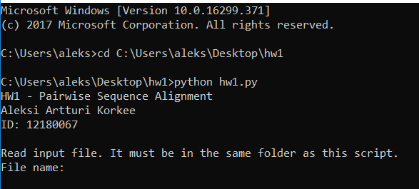

If it does not work then substitute **python** with the **path_to_python\python.exe** which is in my case C:\Users\aleks\AppData\Local\Programs\Python\Python36\python.exe.

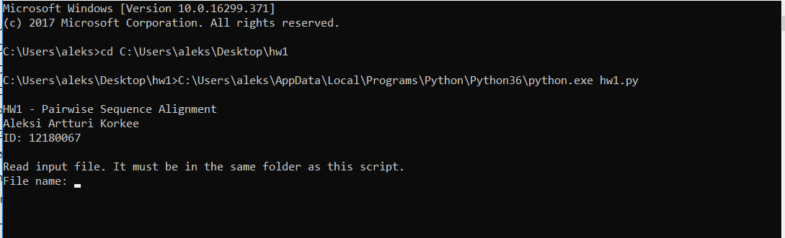

Errors might occur if you have also python 2.7 installed. In this case it might be easier to run the script with Method 3.

**Method 3:**

Install some IDE like PyCharm or NetBeans.

https://www.jetbrains.com/pycharm/download/#section=windows

Then run the hw1.py script with the IDE:

Open Pycharm and choose Configure->Settings

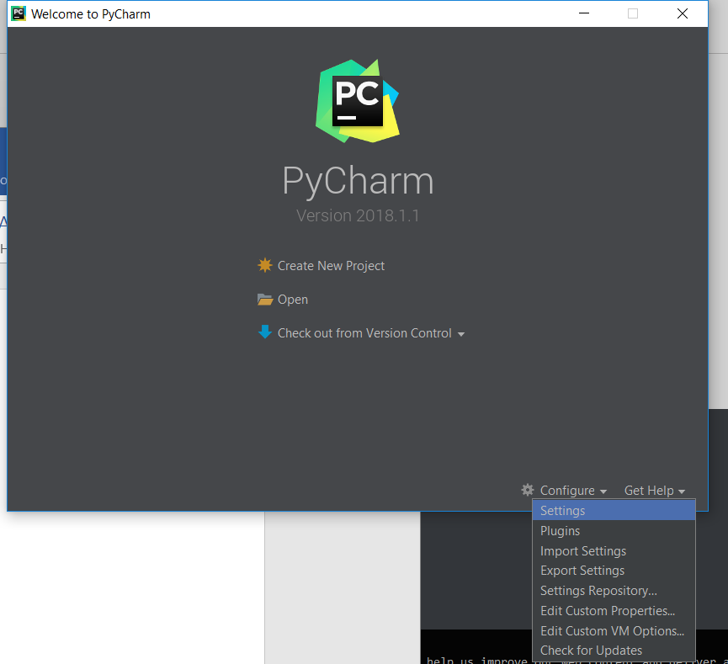

Choose Project Interpreter. If you already have python 3.6 selected, then just click OK. Otherwise click the icon highlighted below and choose Add.

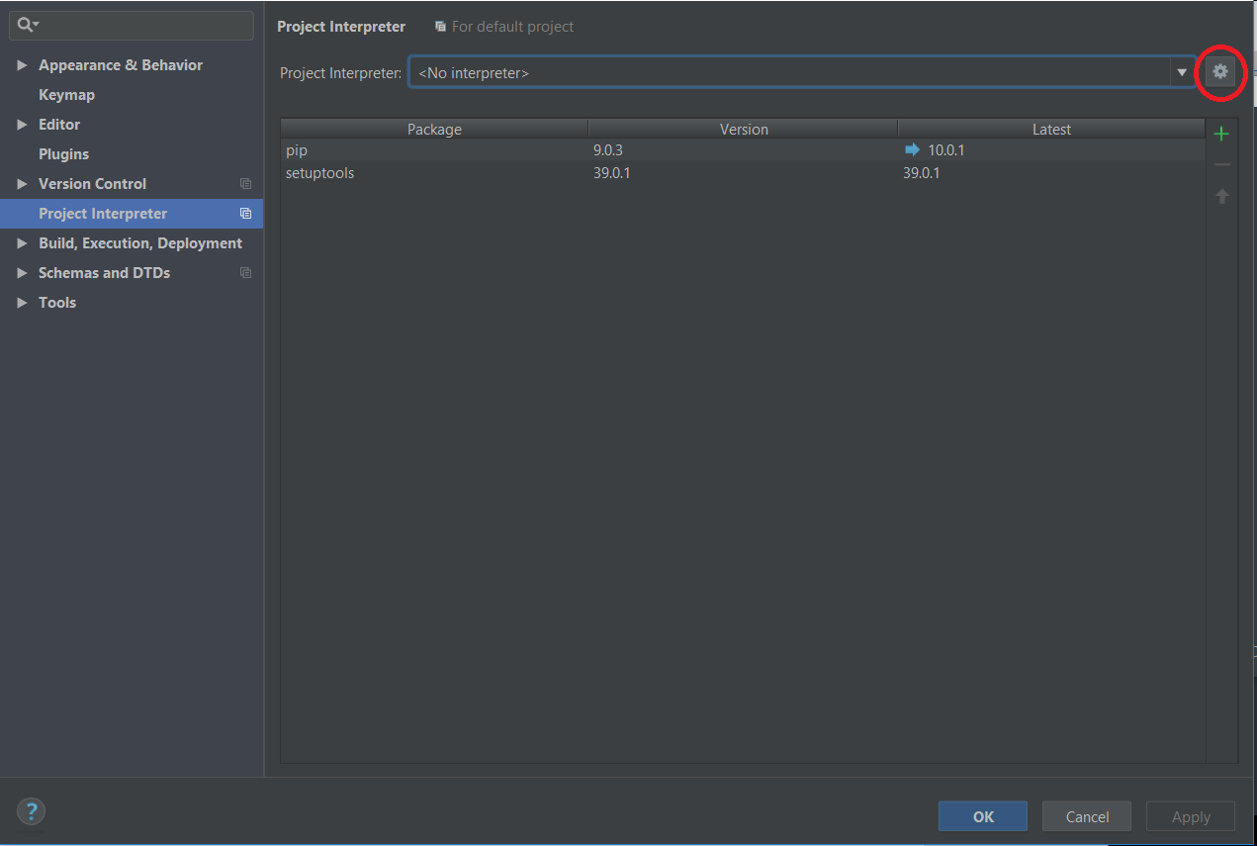

Locate the python.exe from the folder where you installed python 3.6. Then click OK.

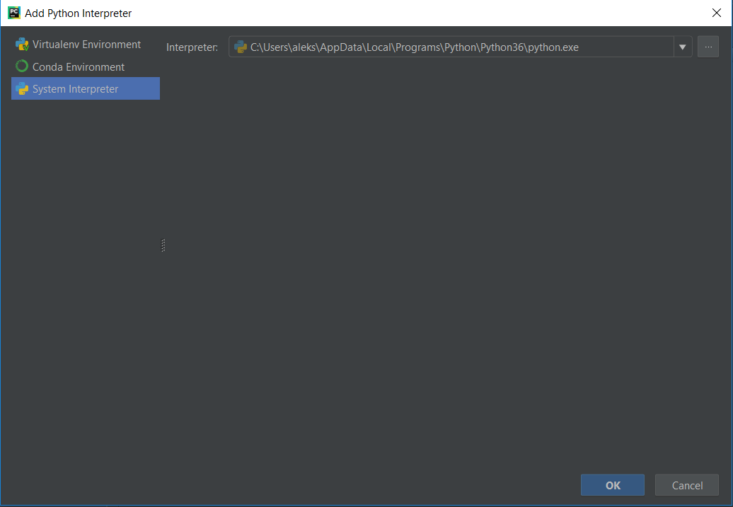

Now create a new project->Choose the source code folder hw1 and choose Python 3.6 as Exiting interpreter. Then click Create.

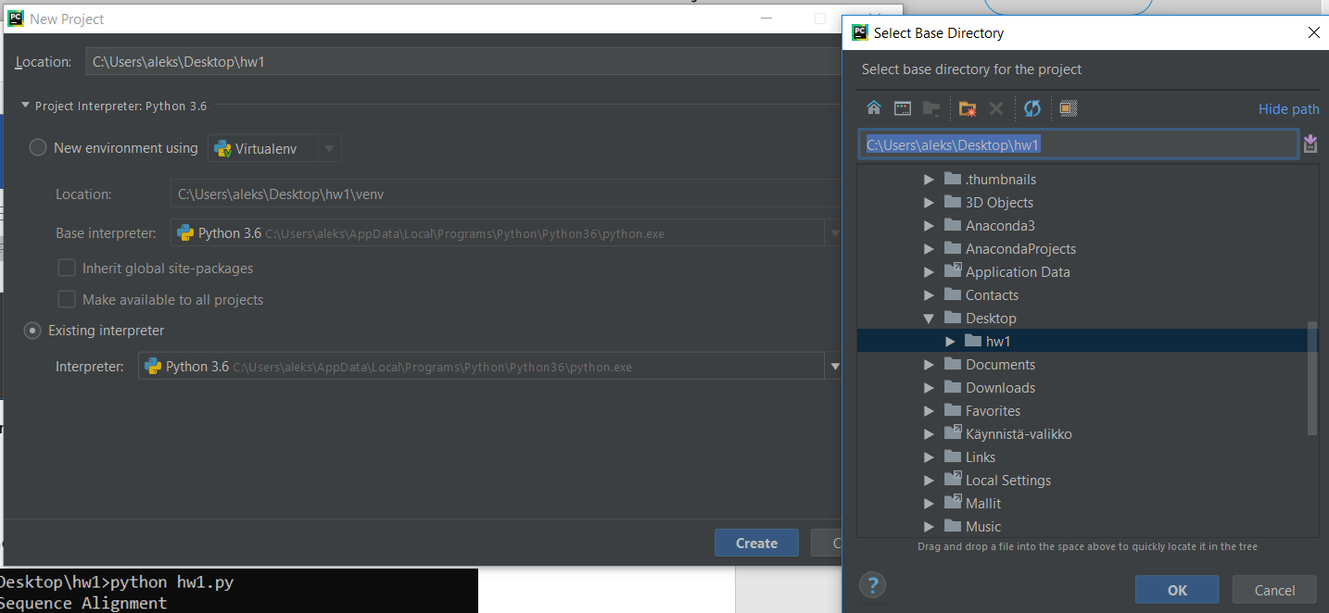

Click **yes** when it asks if you would like to crate a project from existing sources.

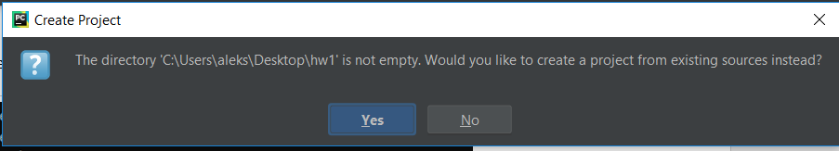

Open hw1.py from the left sidebar.

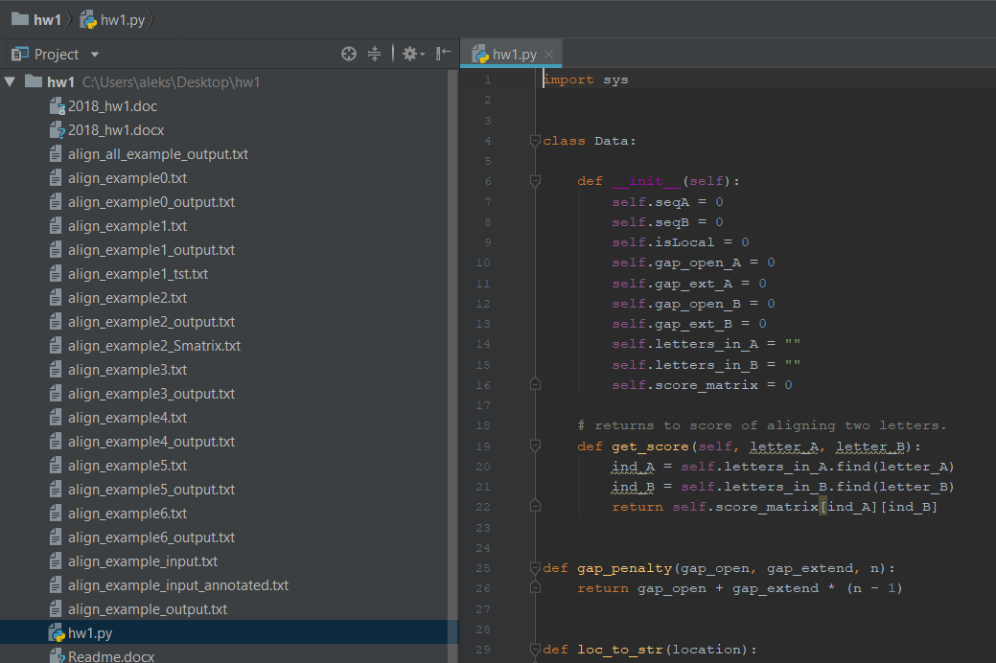

Click run 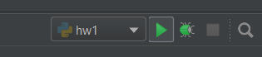 and choose hw1 as configuration if asked.

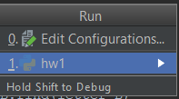.

The program should now work. 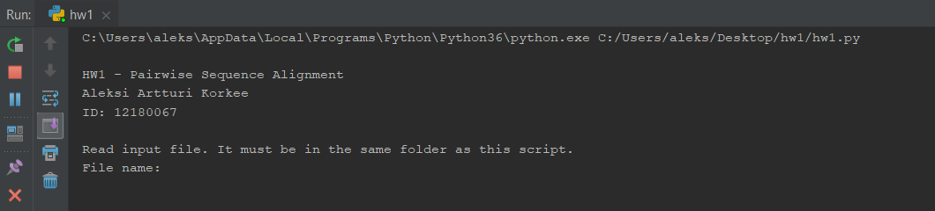

**Using the program**

The program asks the file name of a input file. For example running test1_dat.txt:

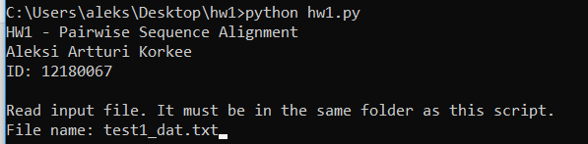

You have to write the name of the file correctly or the program closes.

The program will find the alignments with the best score and prints them in the console:

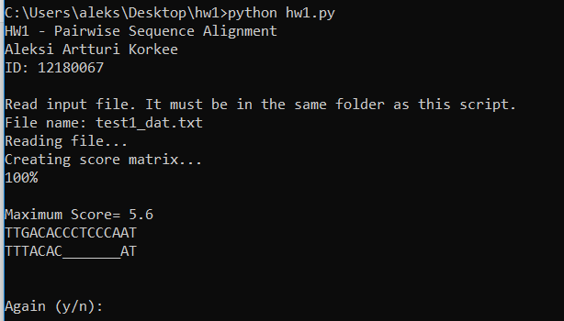

The program asks you if you want to run alignment again. Input **y** if you want to run it again. Input **n** to exit the program.

**Answers to questions**

1. Alignment Score: 5.6
2. Alignment Score: 5.4
3. Answer: TTGACACC
4. Alignment Score: 589.0
5. (5+4+5+4+4+3)/6 = 4.17 -> 4 gaps on average
6. Alignment Score: 586.0
7. (3+2)/2 = 2.5 gaps on average
8. Alignment Score: 580.0
9. 0 gaps
10. Alignment Score: 155.0
11. I
12. K
13. V
14. K
15. Alignment Score: 137.0
16. Alignment Score: 21.4
17. Alignment Score: 27.0
18. Alignment Score: 26.0
19. a. Local alignment
20. b. Decrease
21. b. Decrease